Role: Act as a certified Kubernetes administrator cka, cks, ckd and think like senior architect.

Context: Give ​Architectural Diagram for Rancher rke2 for air gapped environment with a clear diagram of the rke2 highlevel with 3 control plane nodes with etcd, worker nodes, network architecture, including cilium as network plugin, F5 load balancer for nginx ingress, hashicorp vault for secret management, longhorn storage , Prometheus with thanos, jenkins ci/cd, jfrog artifactory for mirror images, all firewall rules, required ports.

Action: Research and give best highly professional Architectural low-level design diagram.

Format: This should use mermaid and include all required details in architectural low-level design diagram.

Tone: Add required colours for components and flow lines.

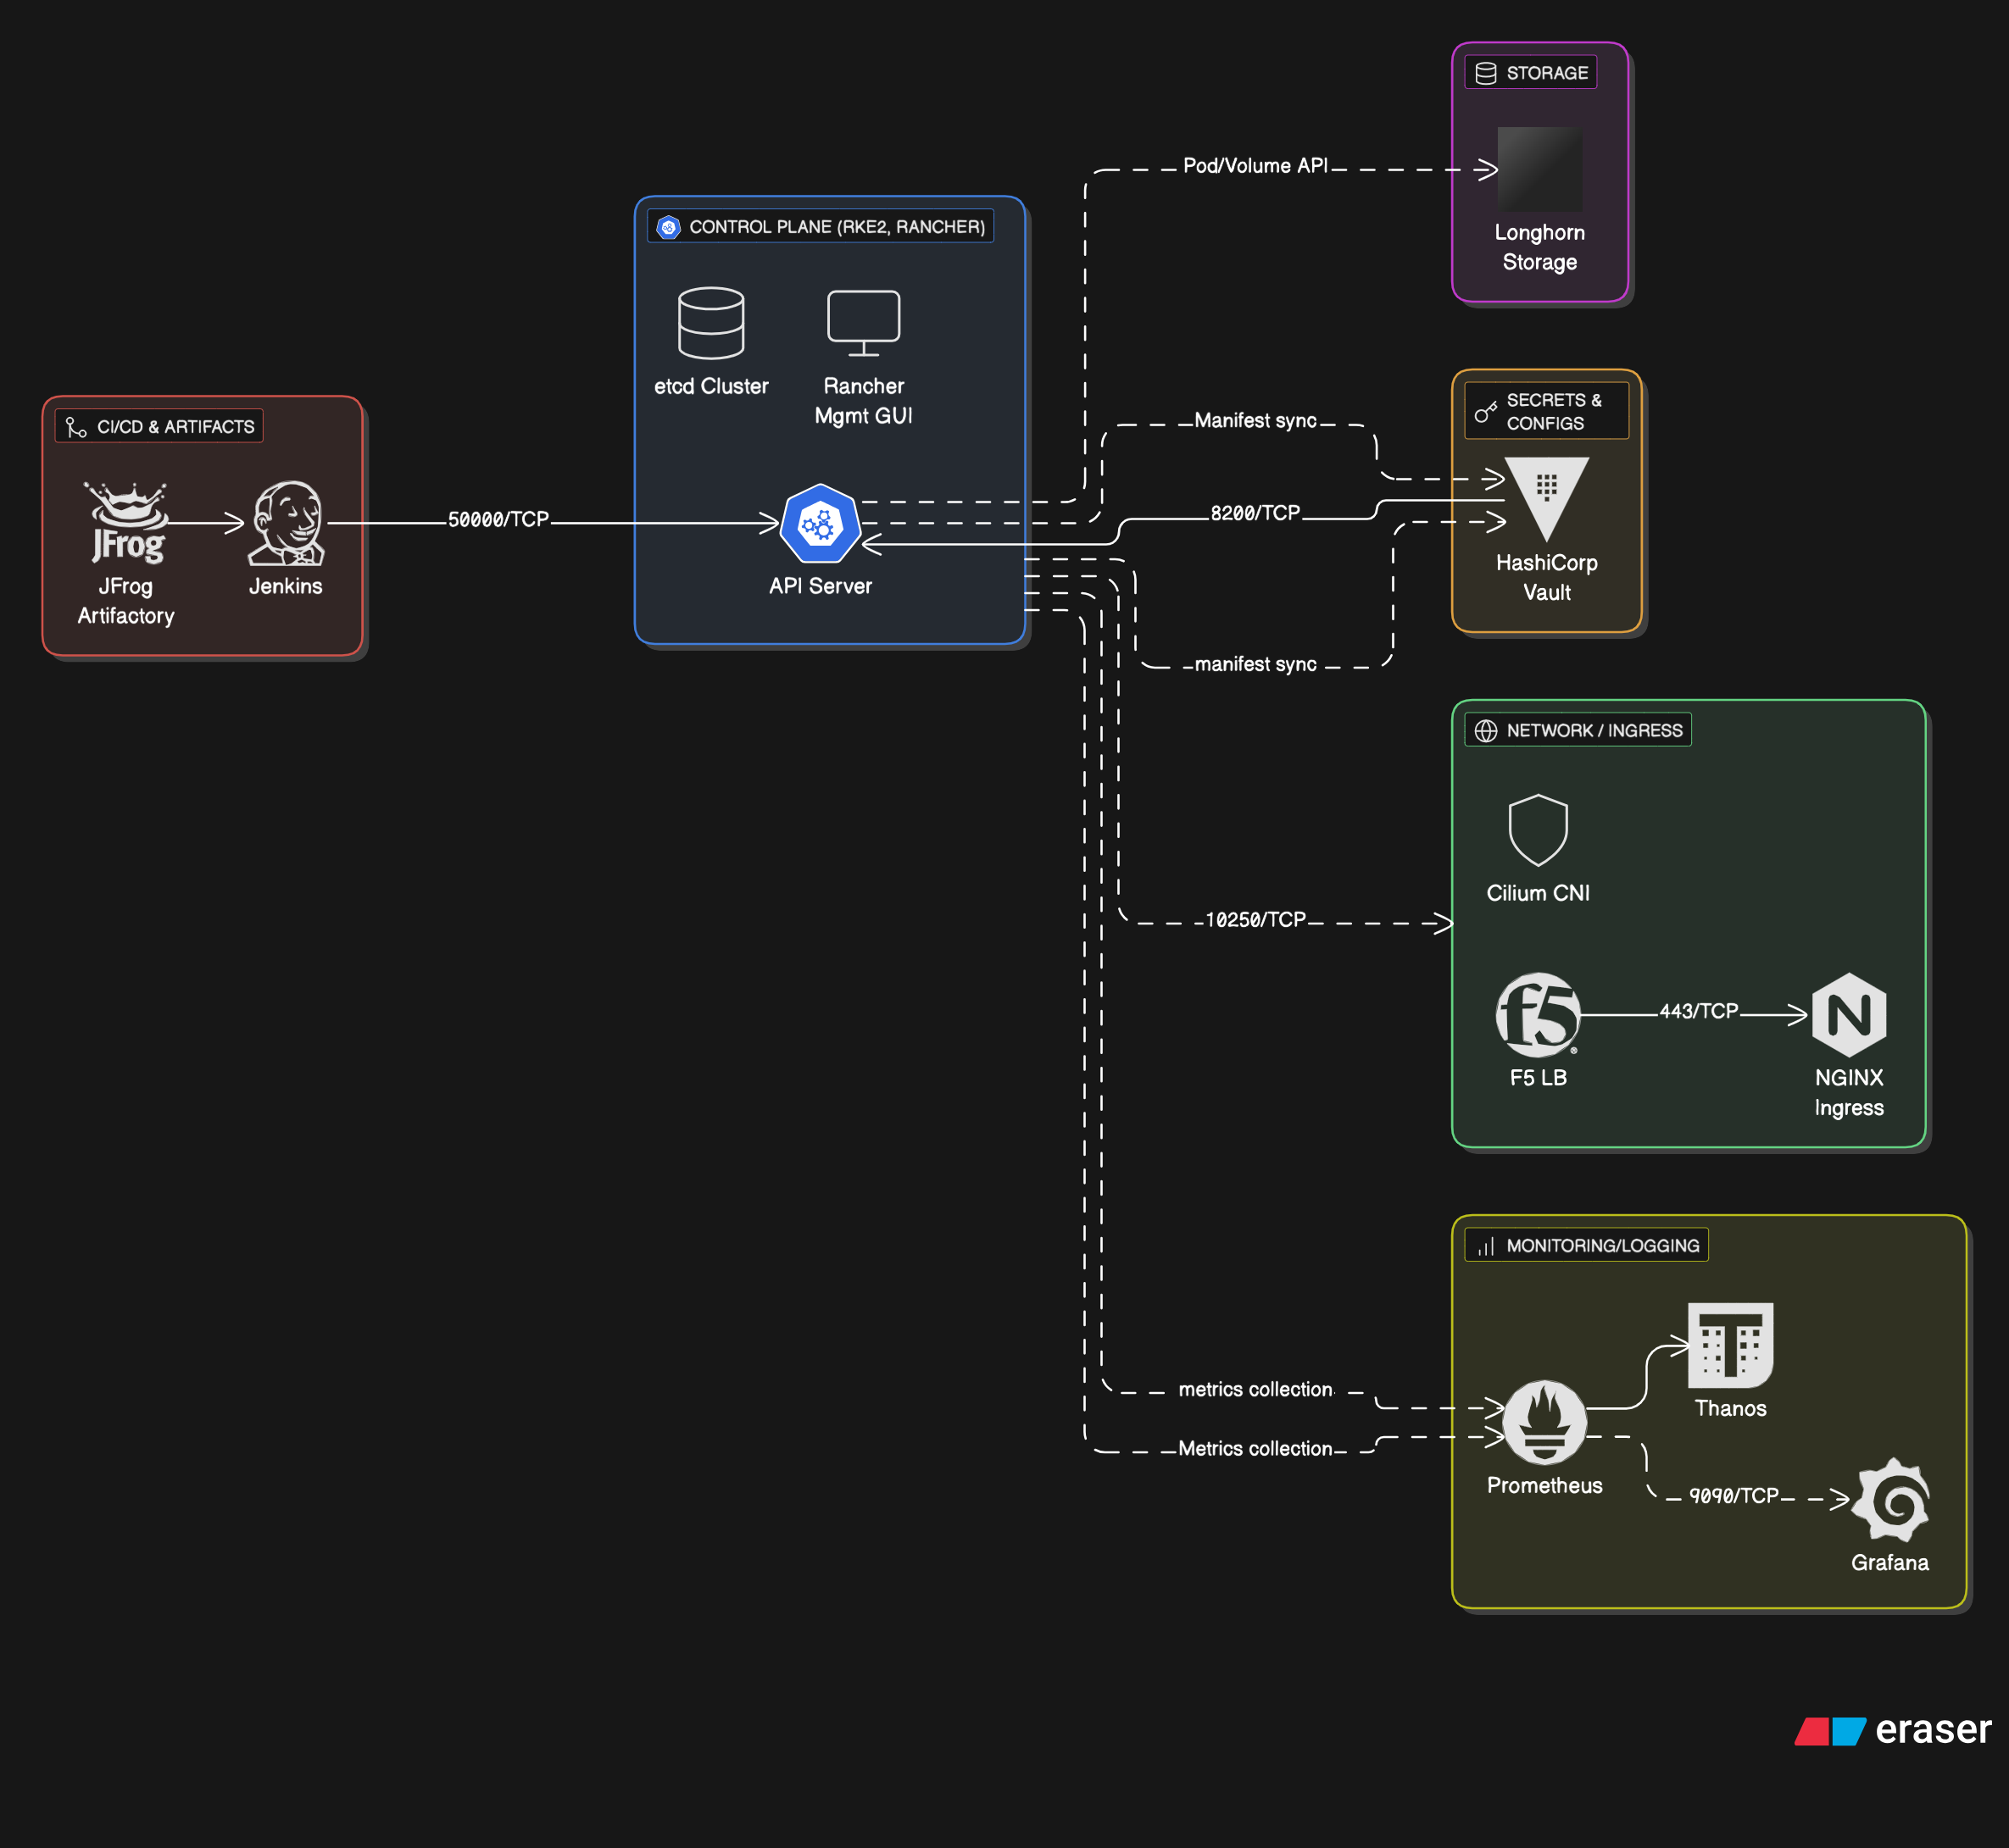

C zxccvvcc/c